1.

MySQL [classicmodels]> select customerNumber,customerName,contactFirstName,phone from customers where city like"S%";

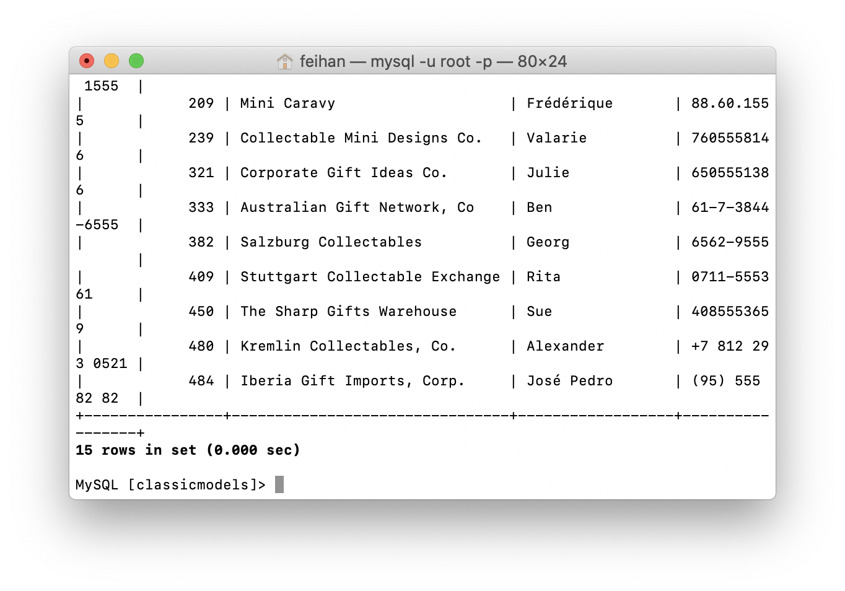

2.

MySQL [classicmodels]>

select employeeNumber, CONCAT(firstName,lastName), jobTitle from employees where reportsTo=CONCAT('Gerard',' Bondur');

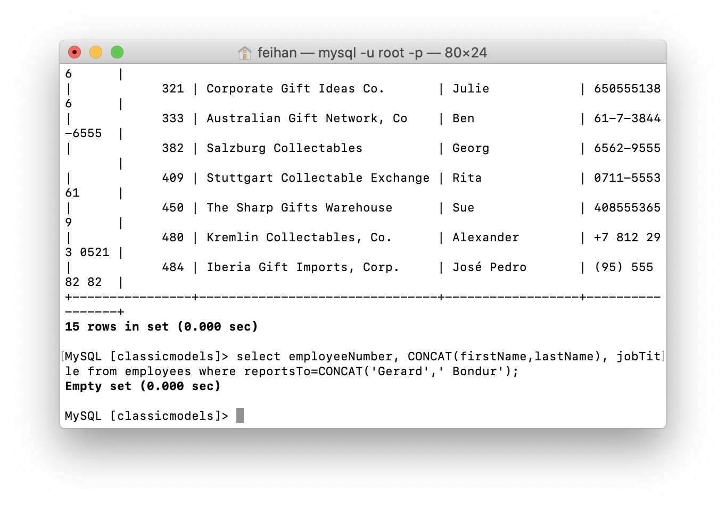

3.MySQL [classicmodels]> select count(productCode),productLine,sum(quantityInStock) from products group by productLine having sum(quantityInStock)>30000;

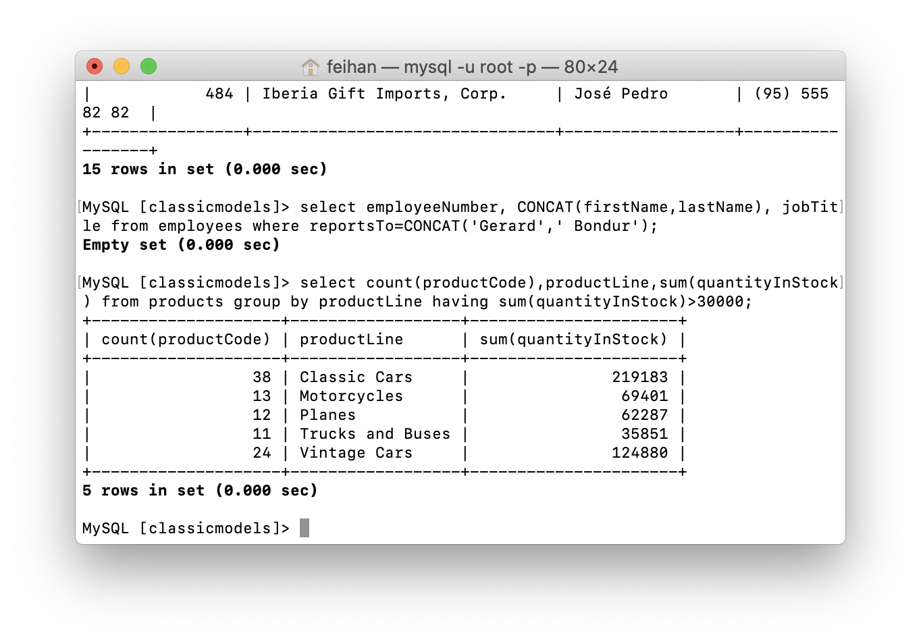

4. MySQL [classicmodels]> select customers.customerNumber,customers.customerName from customers,orders,orderDetails,products where customers.customerNumber=orders.customerNumber and orders.orderNumber=orderDetails.orderNumber and orderDetails.productCode=products.productCode and products.productName='2003 Harley-Davidson Eagle Drag Bike';

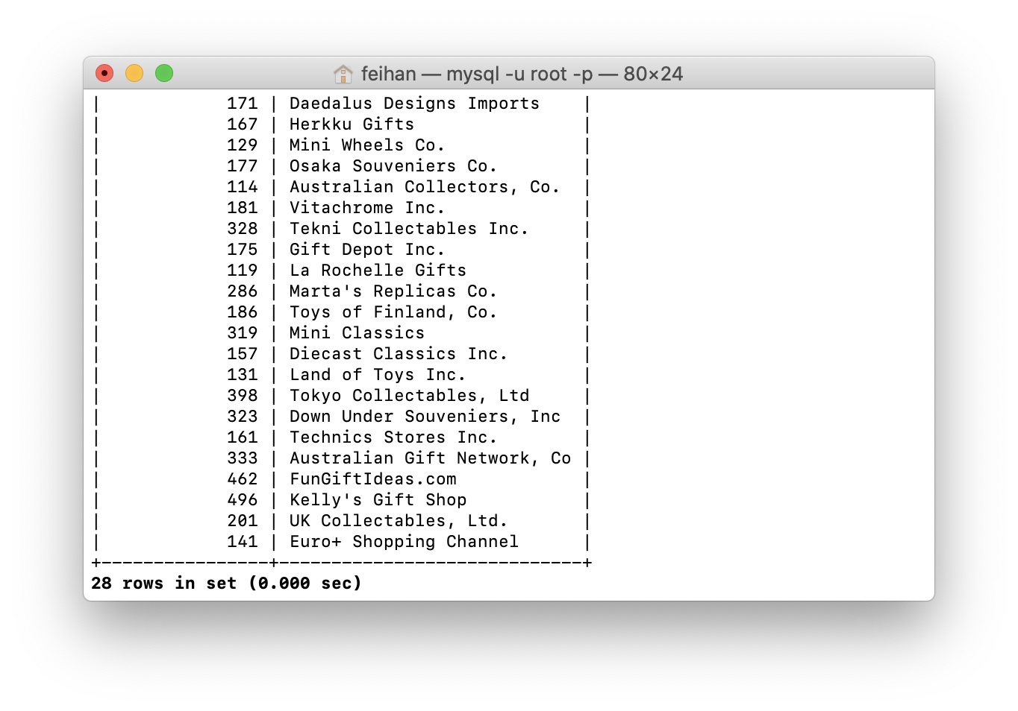

5.

MySQL [classicmodels]> select employees.employeeNumber,CONCAT(employees.firstName,employees.lastName),employees.email from employees,offices where offices.country='America';

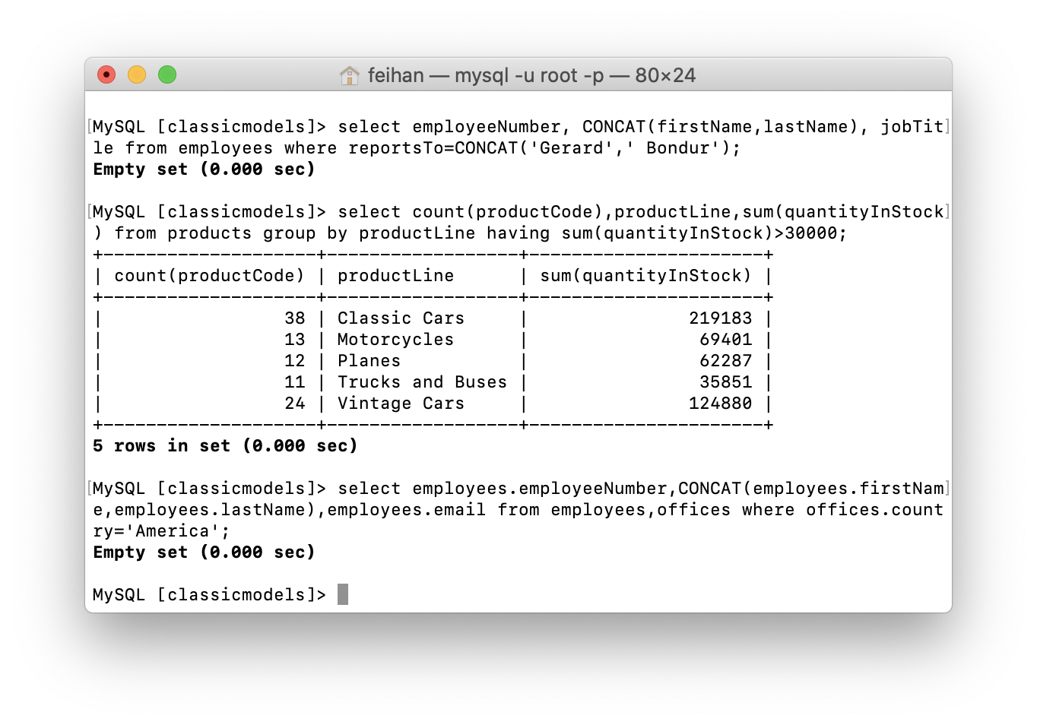

6.

MySQL [classicmodels]> select orderNumber,productCode,quantityOrdered,priceEach,orderLineNumber from orderDetails groupby orderNumber having sum(quantityOrdered*priceEach)>58000;

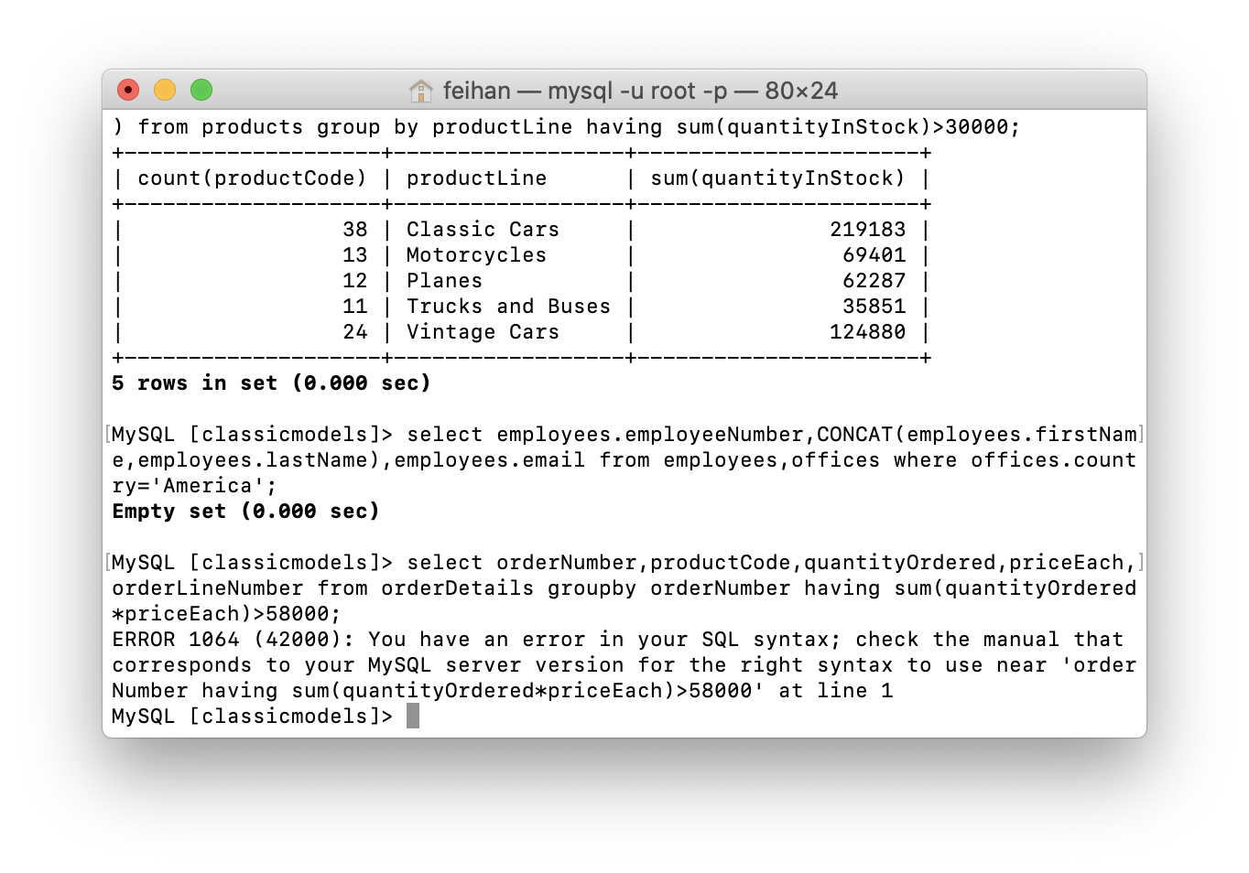

7.

MySQL [classicmodels]> select *, TIMESTAMPDIFF(day,shippedDate,requiredDate) from orders where status='resolved';

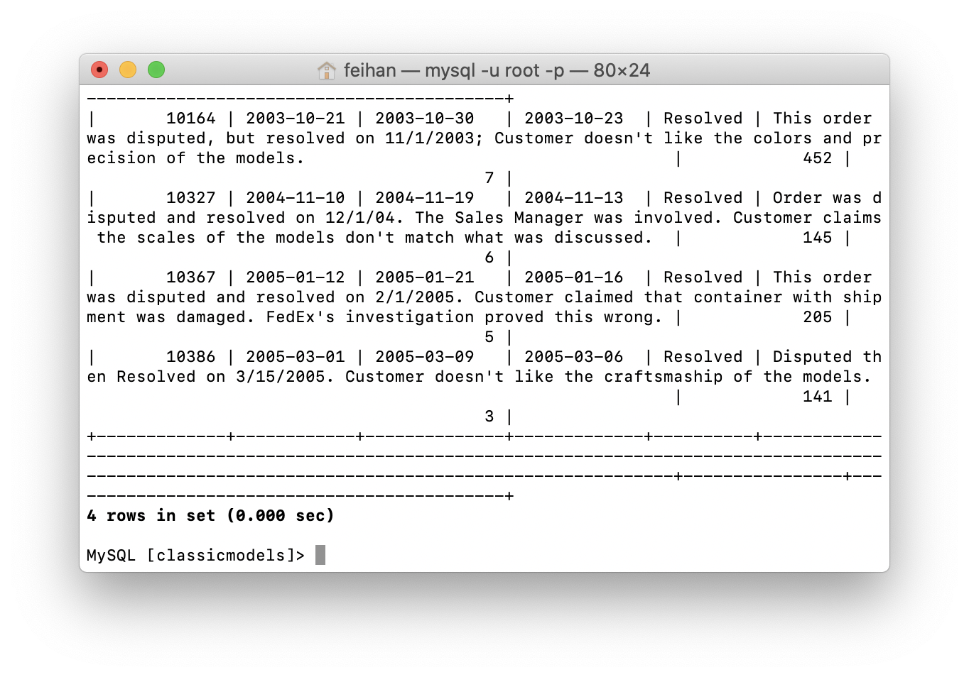

8.MySQL [classicmodels]> select customers.customerNumber,customers.customerName,payments.paymentDate,payments.amount from customers,payments where customers.customerNumber=payments.customerNumber and TIMESTAMPDIFF(year,payments.paymentDate,'2020-10-08')>16 order by payments.paymentDate,payments.amount;

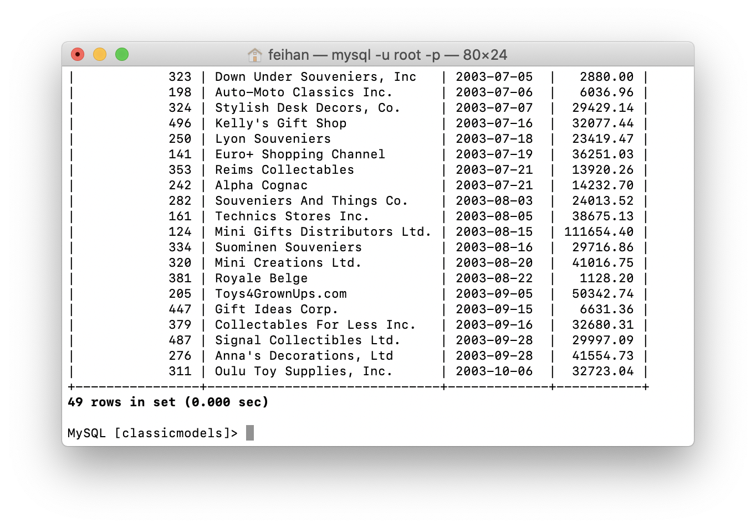

9.

10.

MySQL [classicmodels]> select * from products;

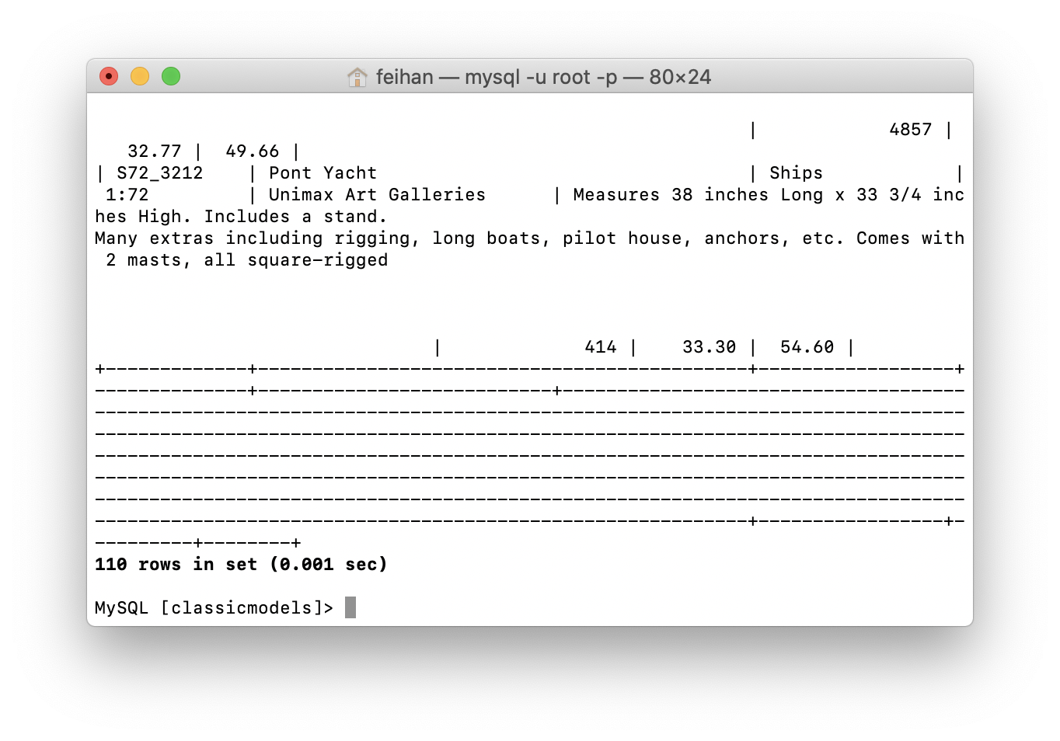

MySQL [classicmodels]> insert into products values ('S88_1999','1899 Kereta-keretaan','trains',5,'Vendor','Kereta api',1,600000,5);

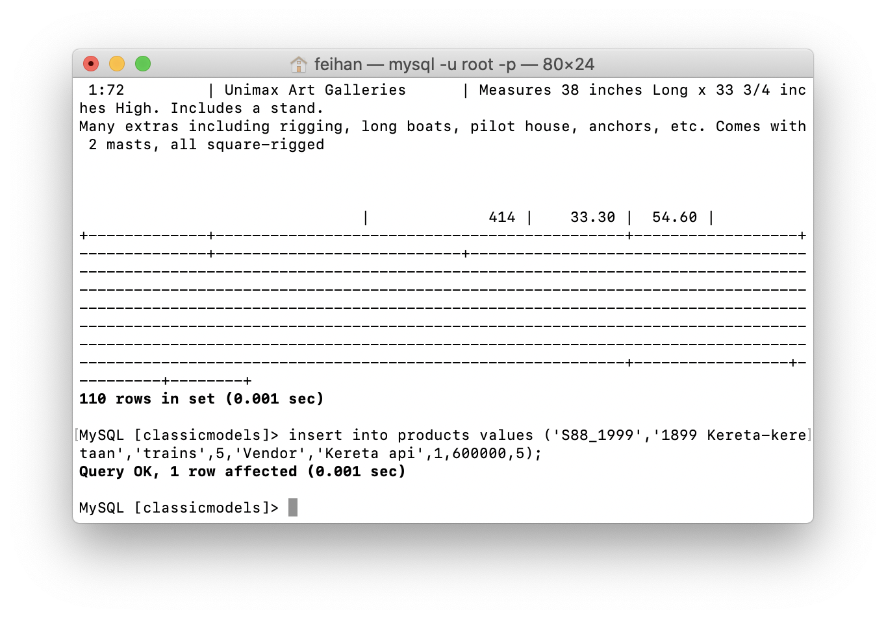

MySQL [classicmodels]> select * from products;

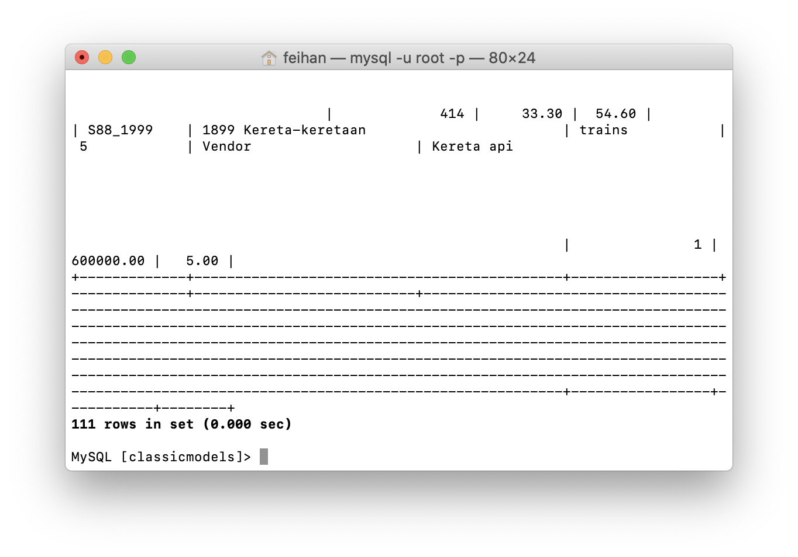

11.

MySQL [classicmodels]> select * from orderDetails;

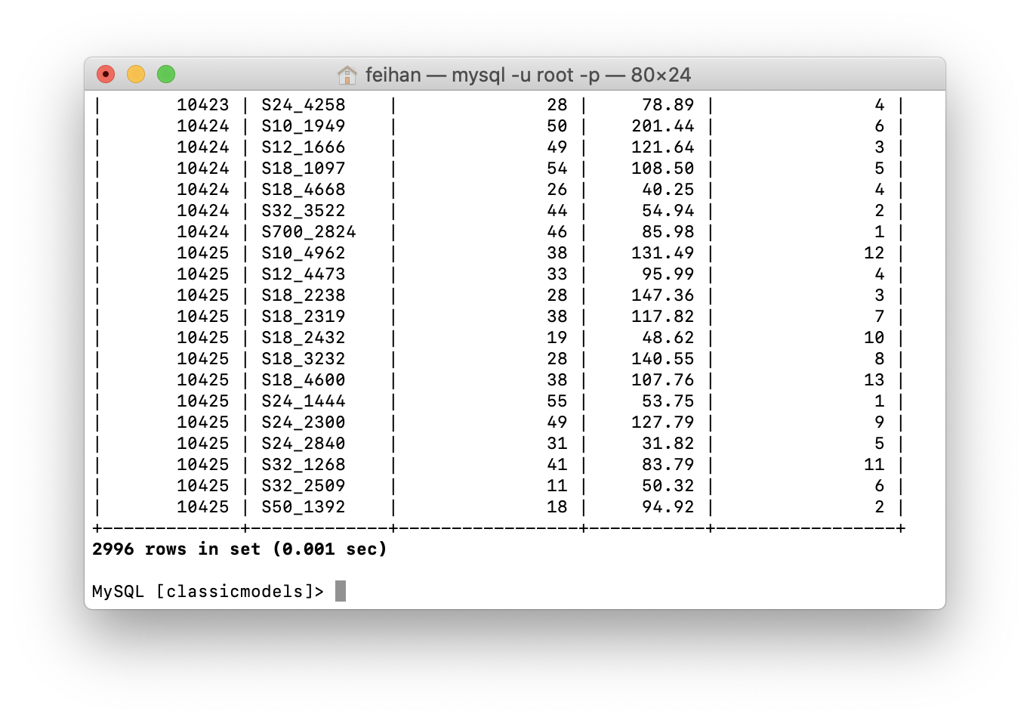

MySQL [classicmodels]> delete from orderDetails where productCode='S24_2766';

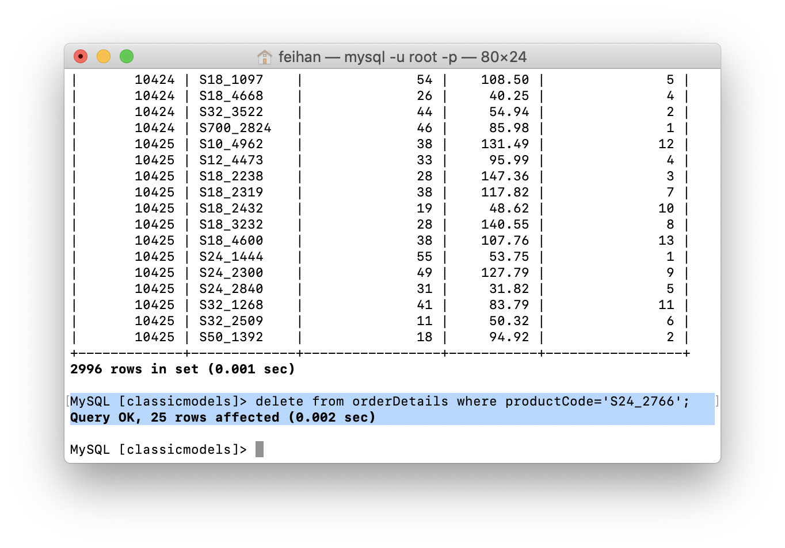

MySQL [classicmodels]> select * from orderDetails;

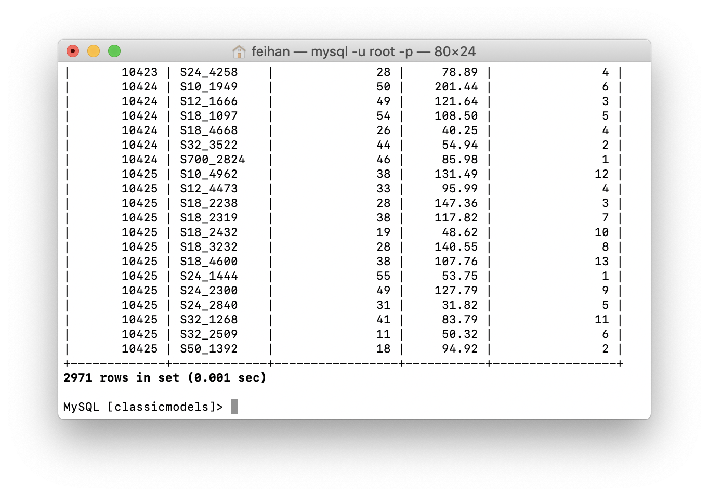

12.

13.

MySQL [classicmodels]> select * productlines;



MySQL [classicmodels]> alter table productlines add created date default '2020-10-08';

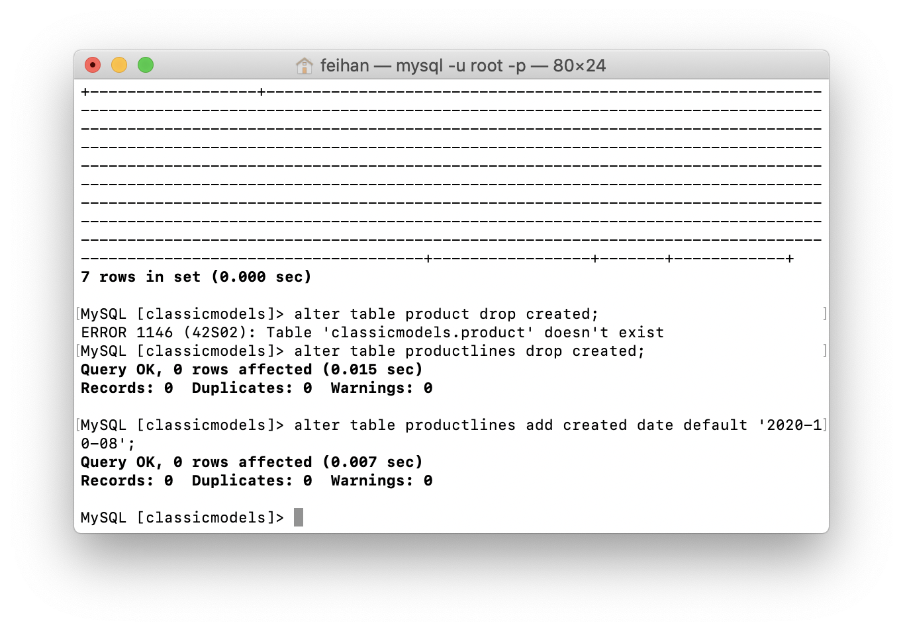

MySQL [classicmodels]> select * productlines;

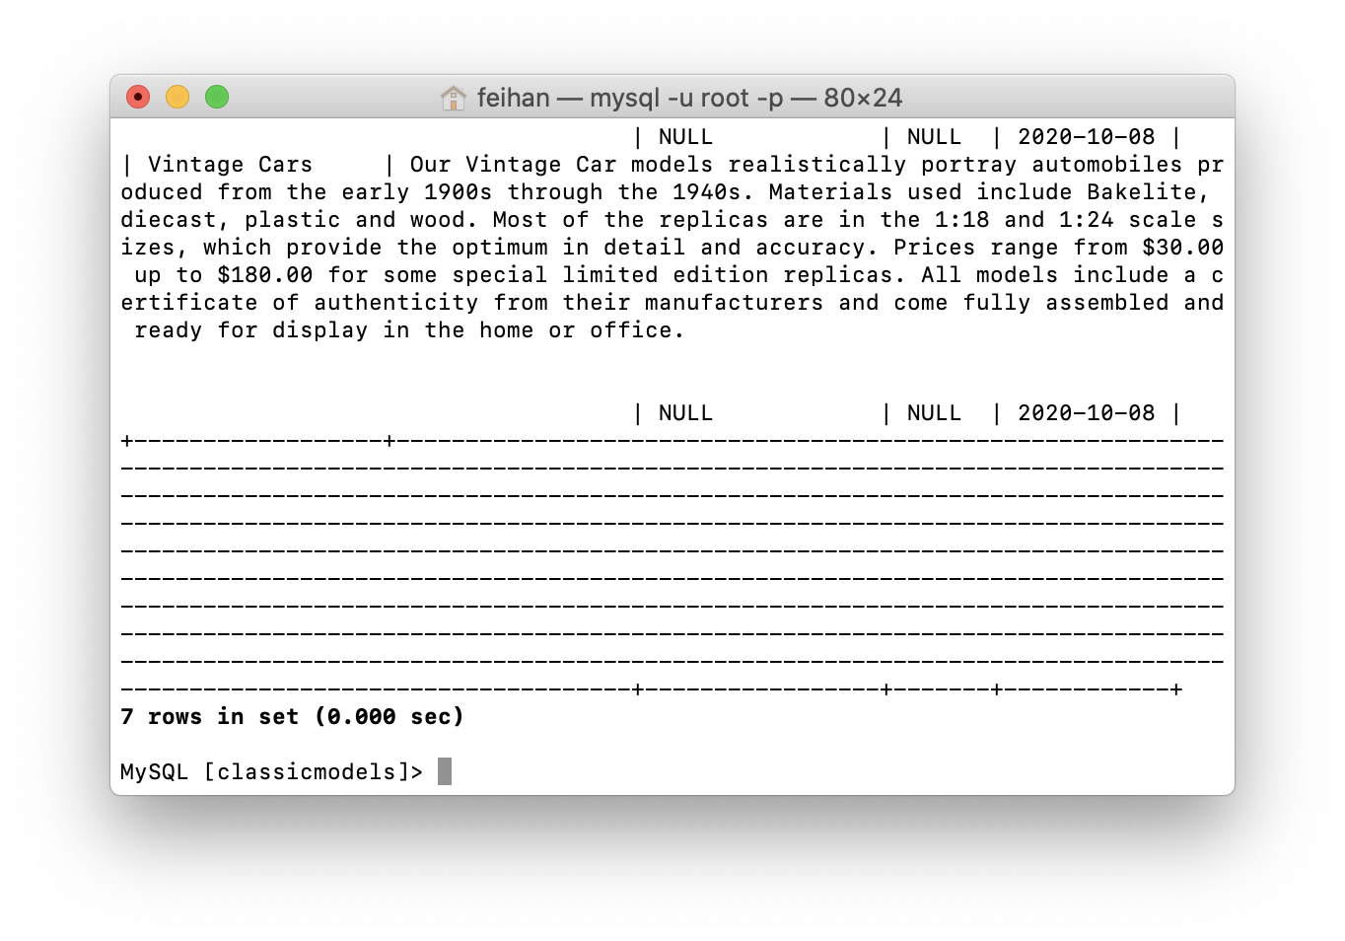

14.

MySQL [classicmodels]> show tables;

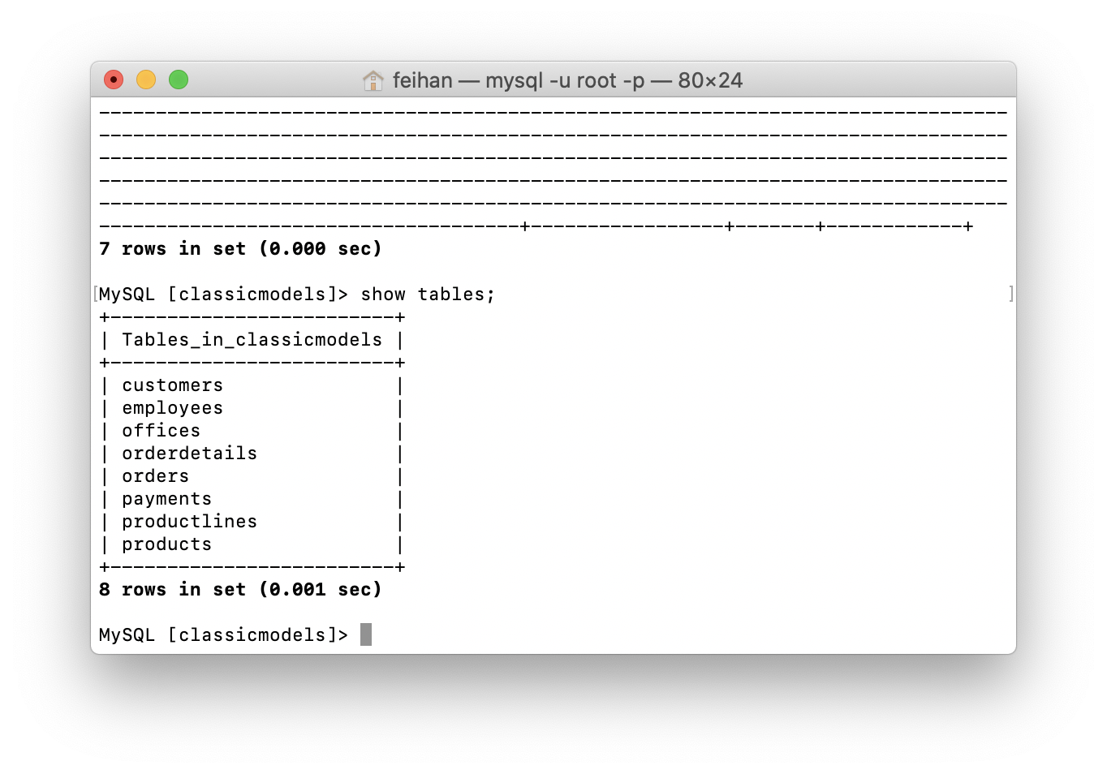

MySQL [classicmodels]> create table if not exists specialemployee(name varchar(255),email varchar(255) not null, primary key(name));

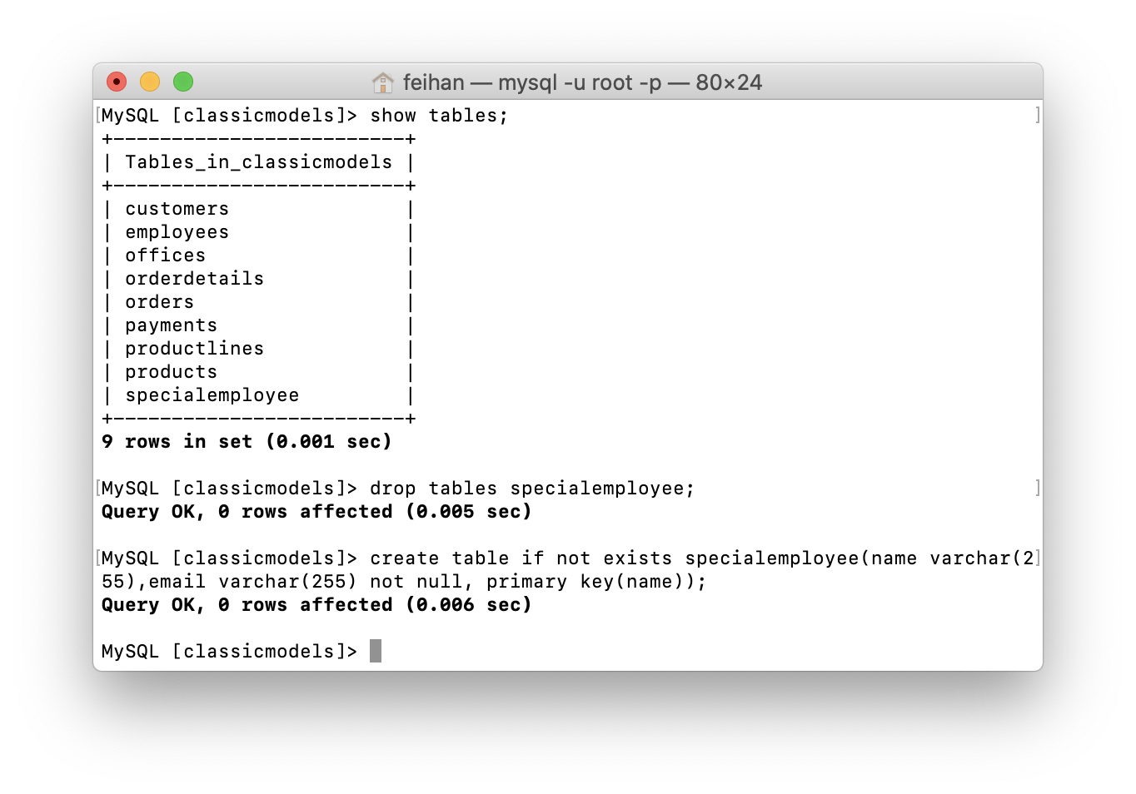

MySQL [classicmodels]> show tables;

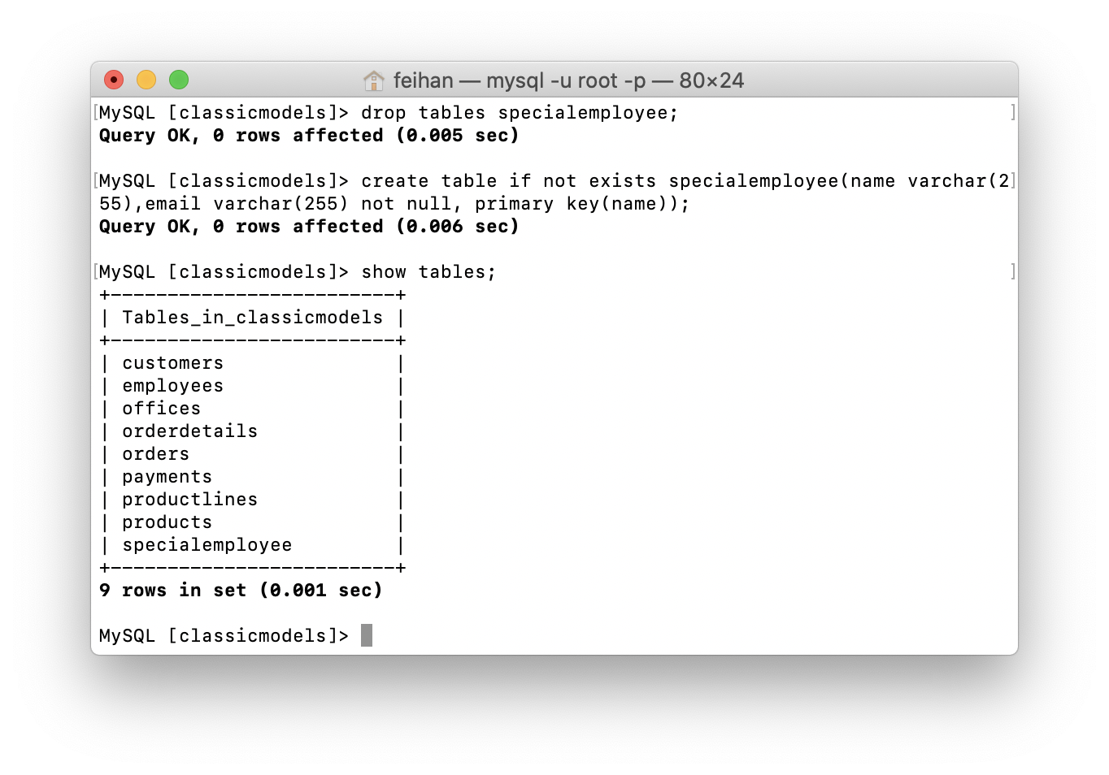

15.

MySQL [classicmodels]> select * from specialemployee;